Indian Sign Language Detection

We have used Yolo11 algorithm for sign detection and recognition and then employing LSTM algorithm for gesture recognition. In below screens showing code and output for each algorithm

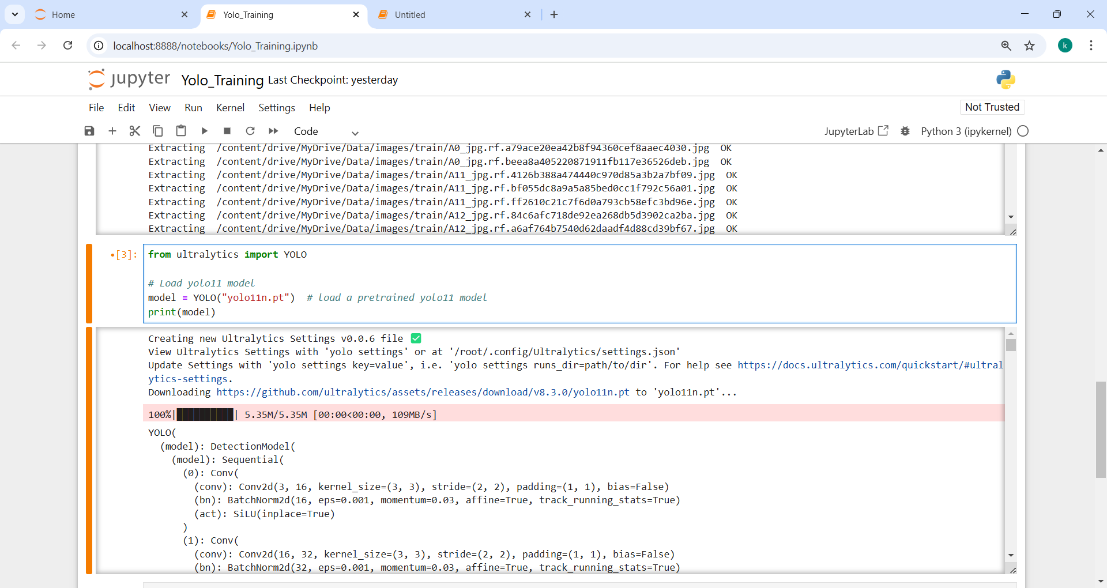

In above screen loading Yolo11 model

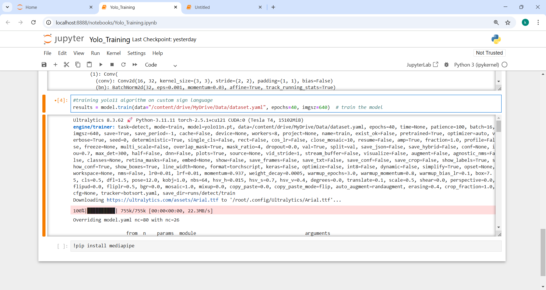

In above screen training Yolo11 algorithm on custom sign language dataset and after training will get below output

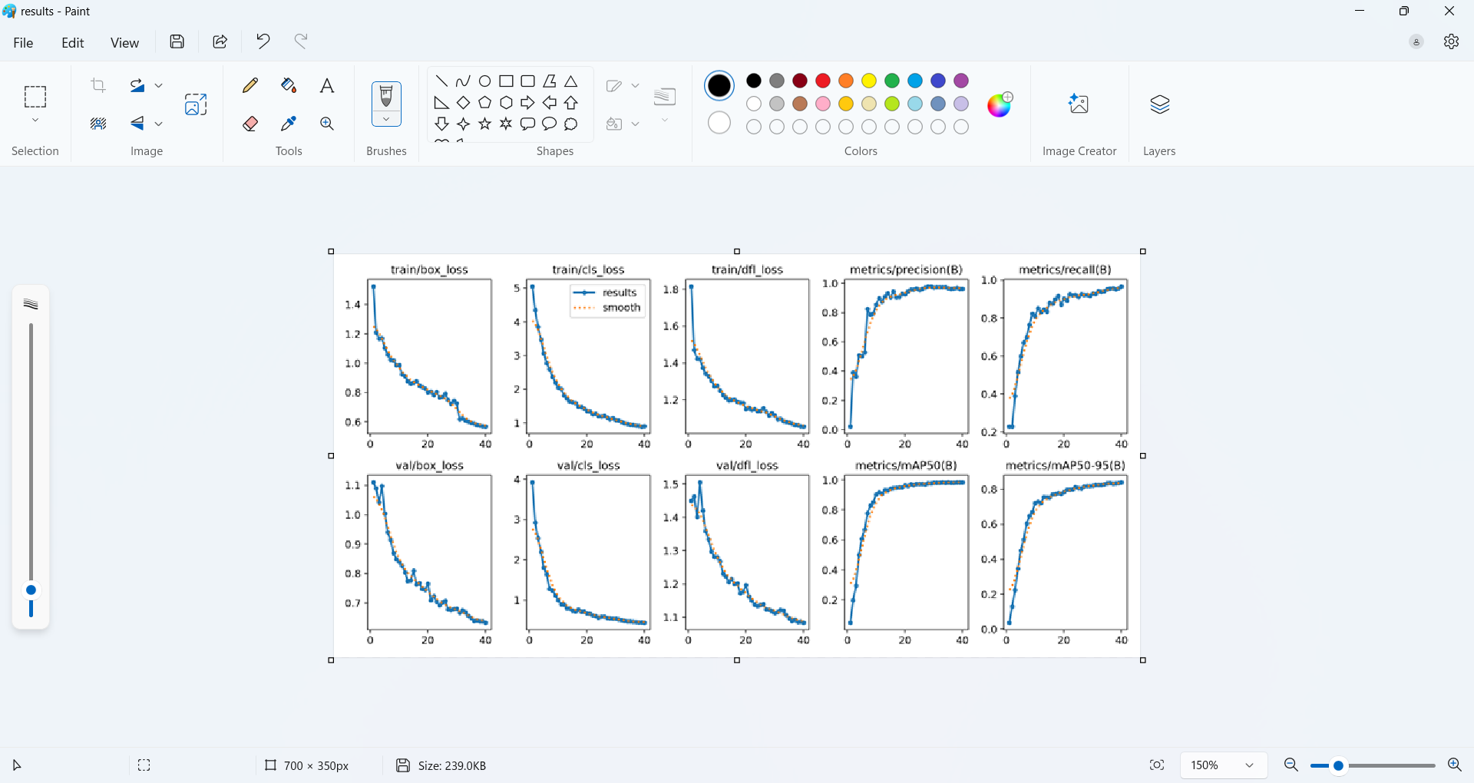

In above screen can see Yolo11 training performance graph for various metrics where loss can see decreasing for each epoch and precision got increased.

Note: Yolo11 cannot be train on normal laptop so we trained on Google COLAB and above are the training output.

In below screen showing sign language dataset images which you can see inside ‘data/train/images’ folder and while executing code you need to show same type of signs from hand for detection and recognition.

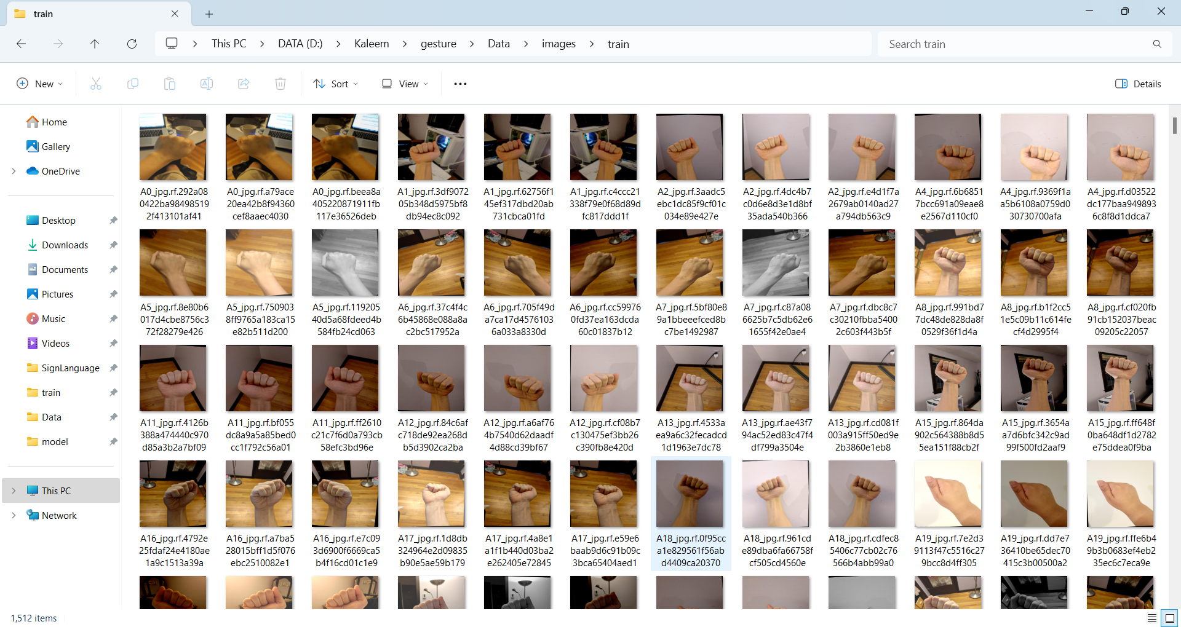

Now in below screens showing code for LSTM training on different gestures and we have used 10 different gestures showing in below screen

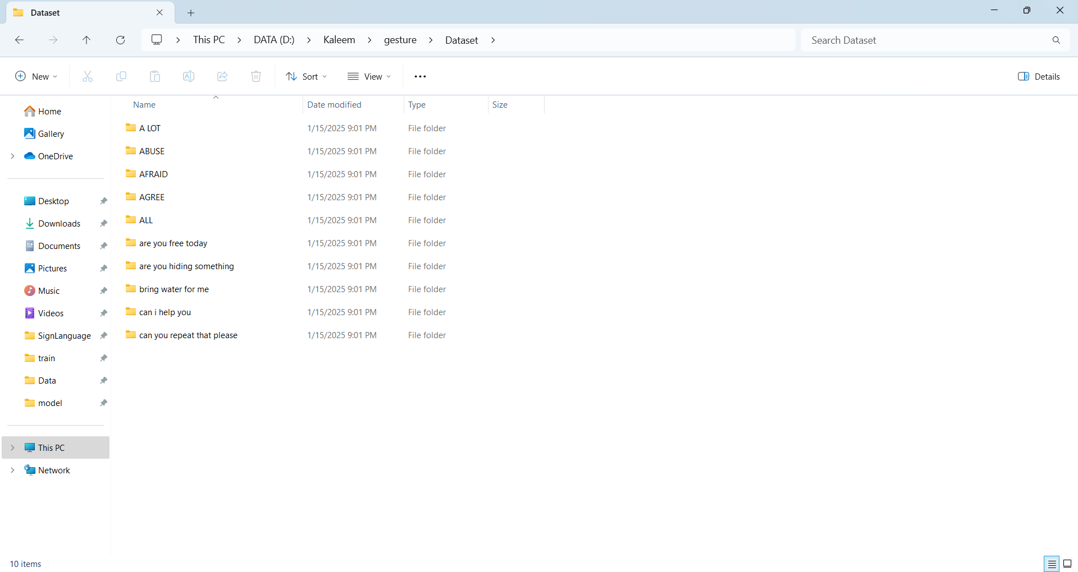

Above images you can see inside ‘Dataset’ folder. In below screens can see coding and training for above dataset

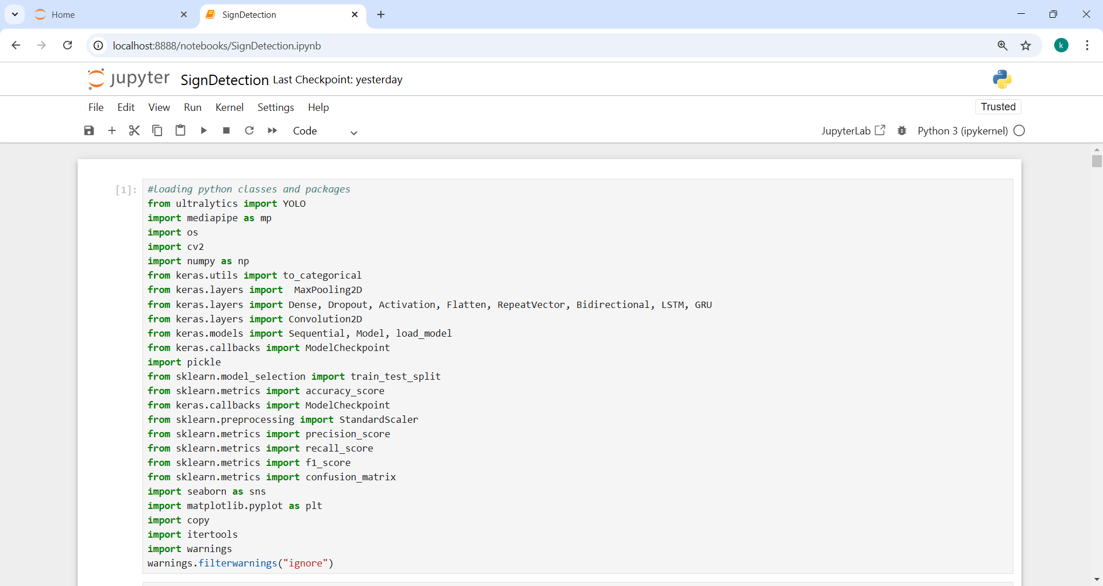

In above screen importing required python classes and packages

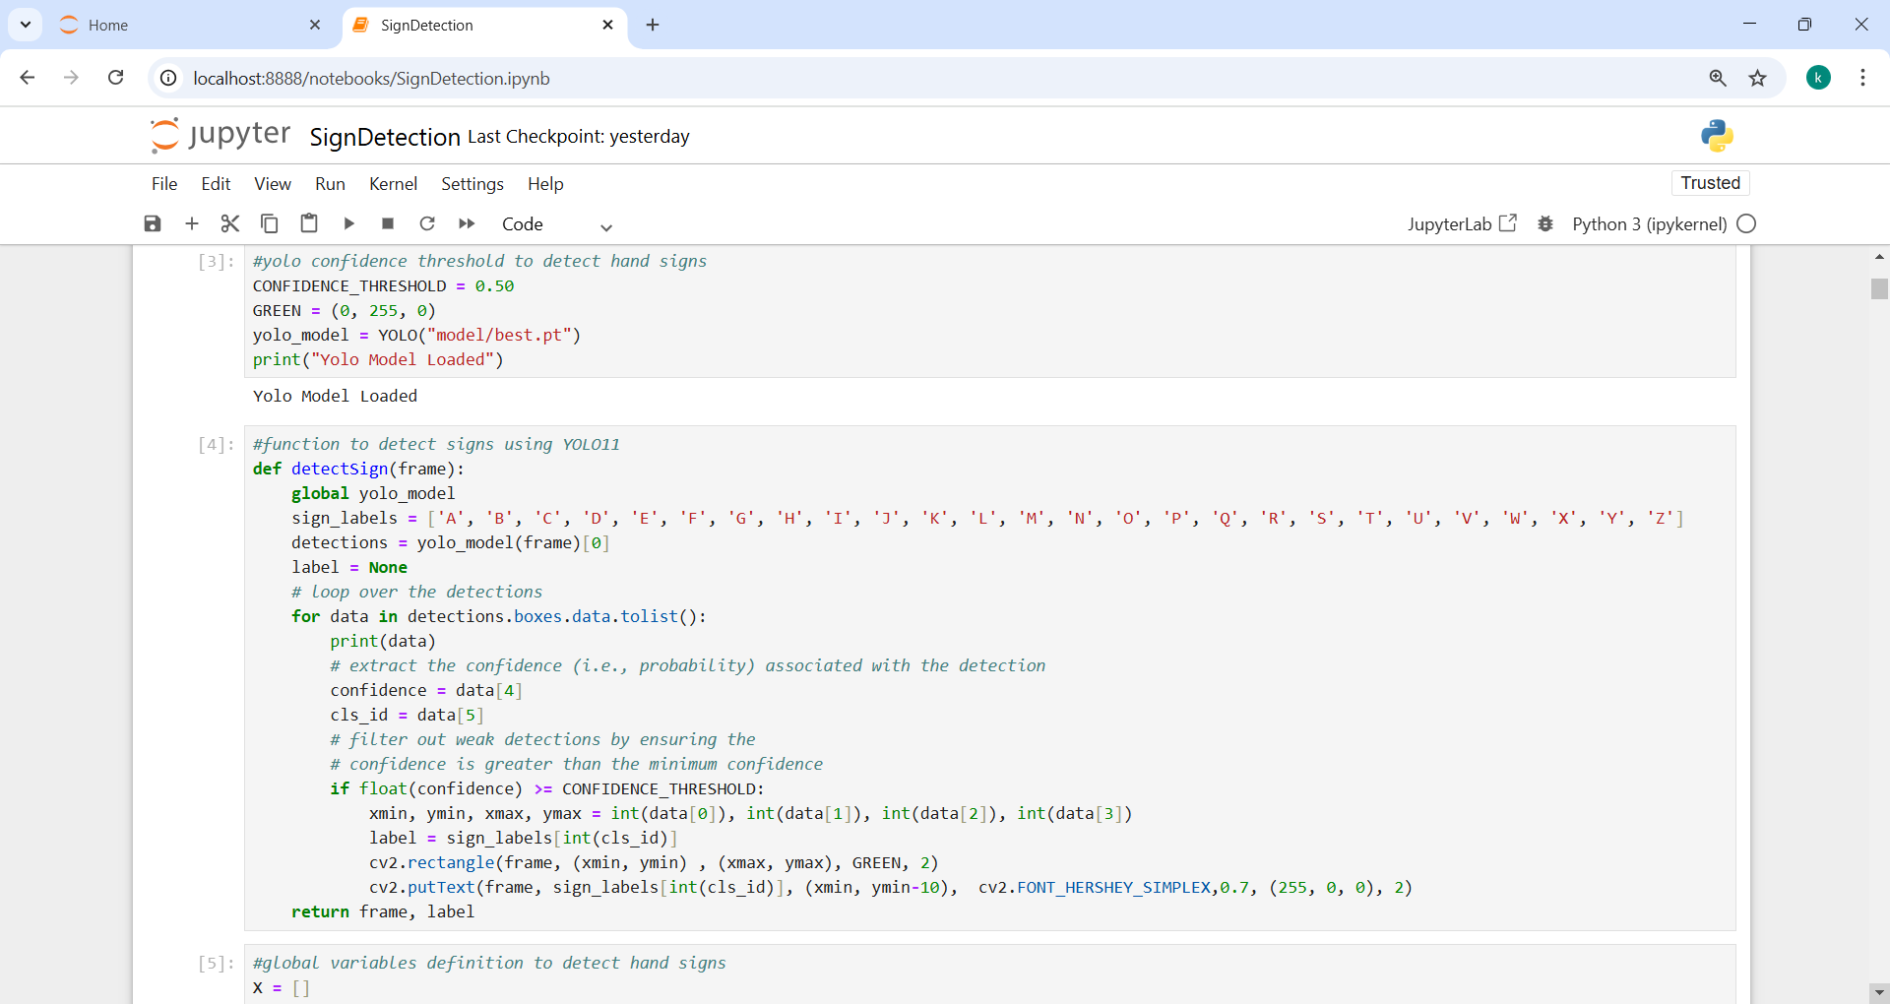

In above screen defining function to load Yolo11 model and then defining function to detect and recognize sign

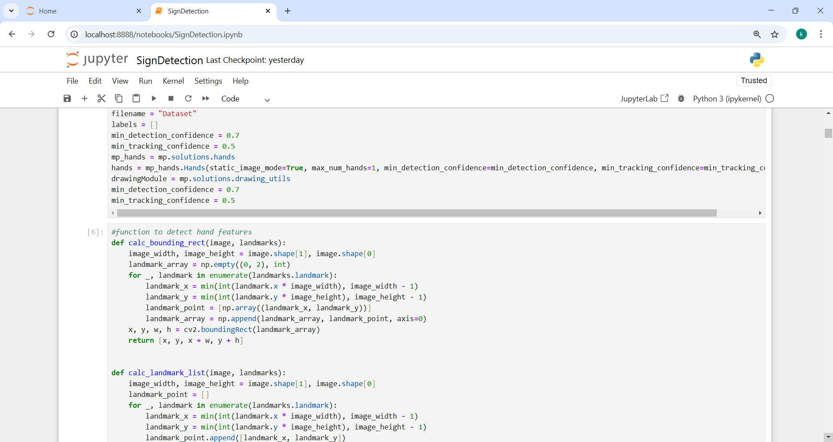

In above screen defining function to detect hands

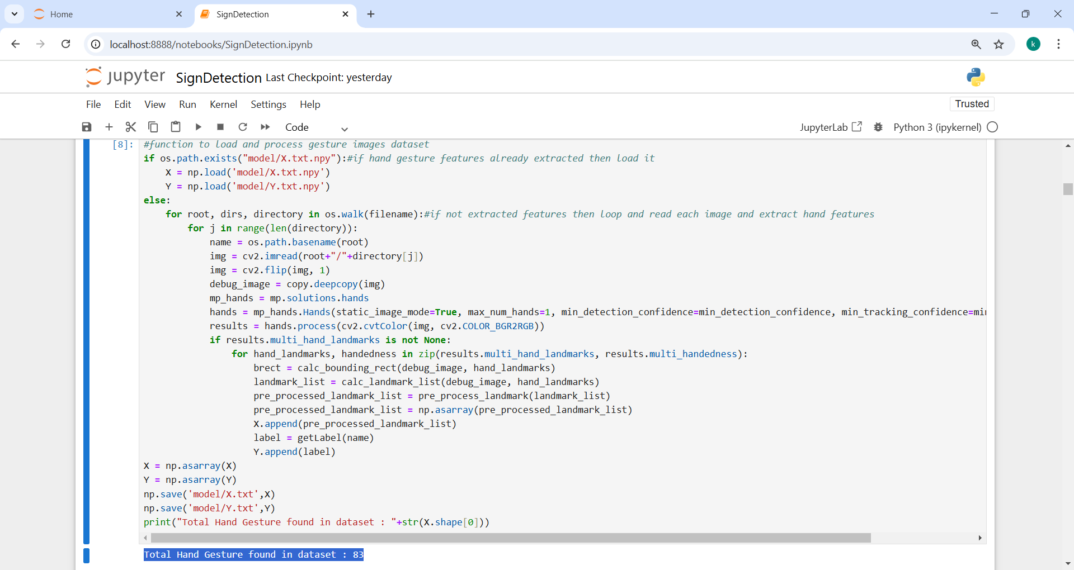

In above screen defining function to load gesture images and then extract features from detected hand and this feature will be used to train LSTM algorithm. In blue color text can see total gesture images loaded as 83

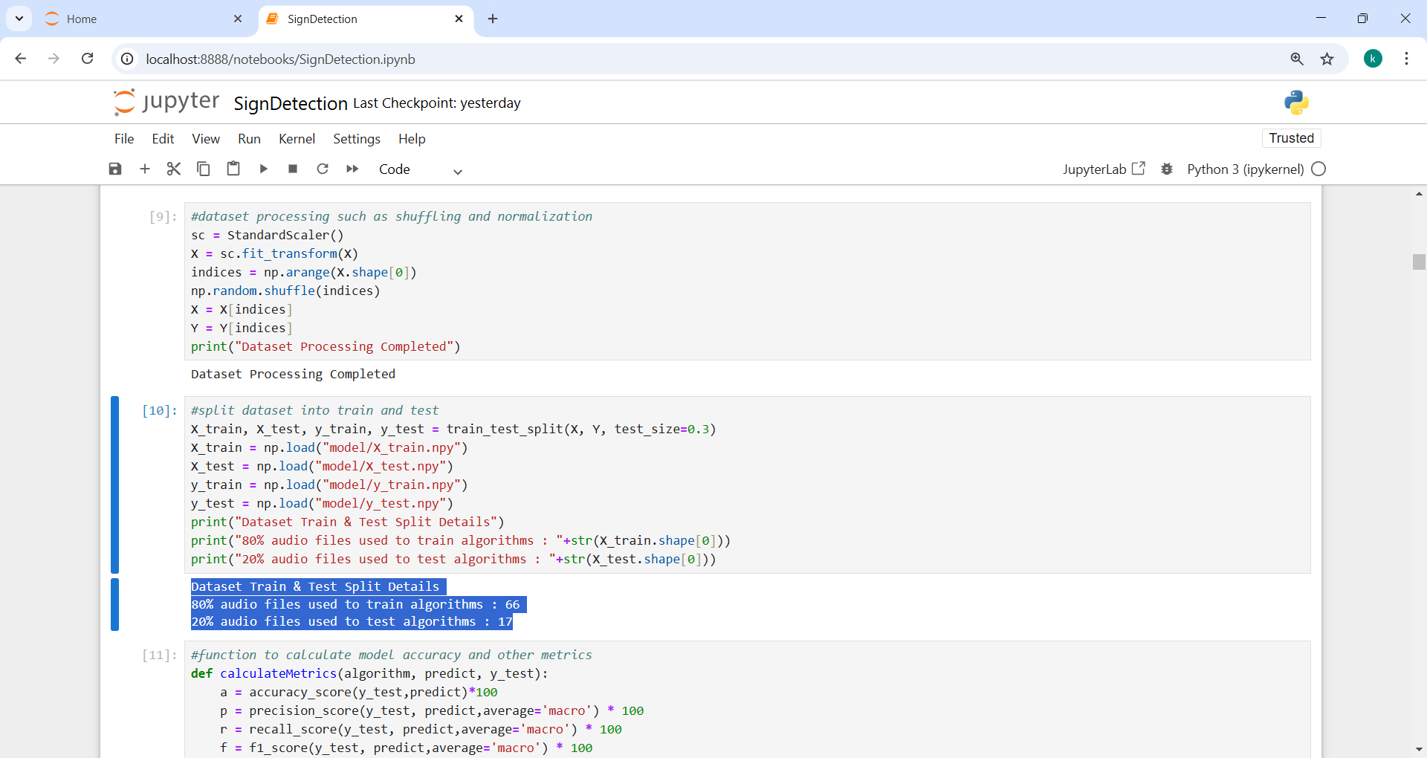

In above screen defining function to normalize extracted features and then splitting features into train and test where application using 80% images features for training and 20% for testing

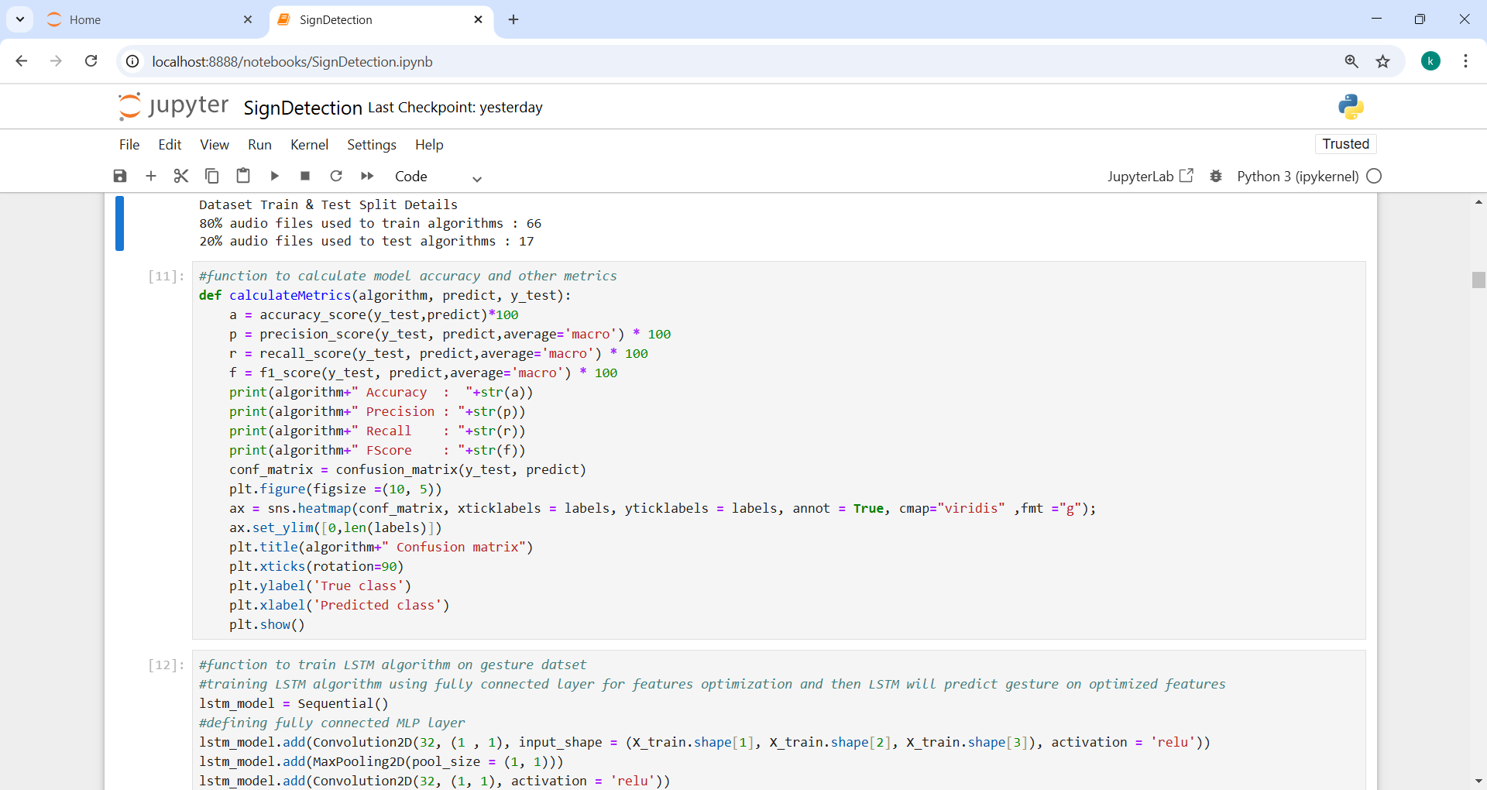

In above screen defining function to calculate accuracy and other metrics

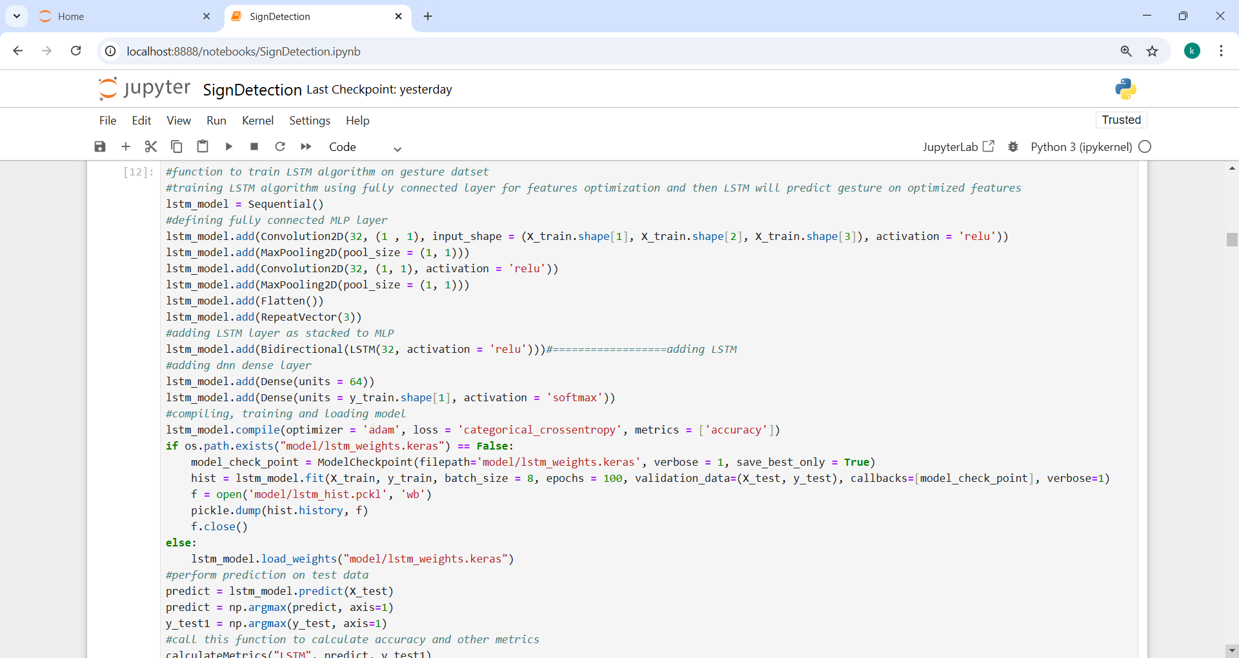

In above screen defining and training LSTM algorithm on 80% training features and then performing prediction on 20% test data to get below prediction accuracy

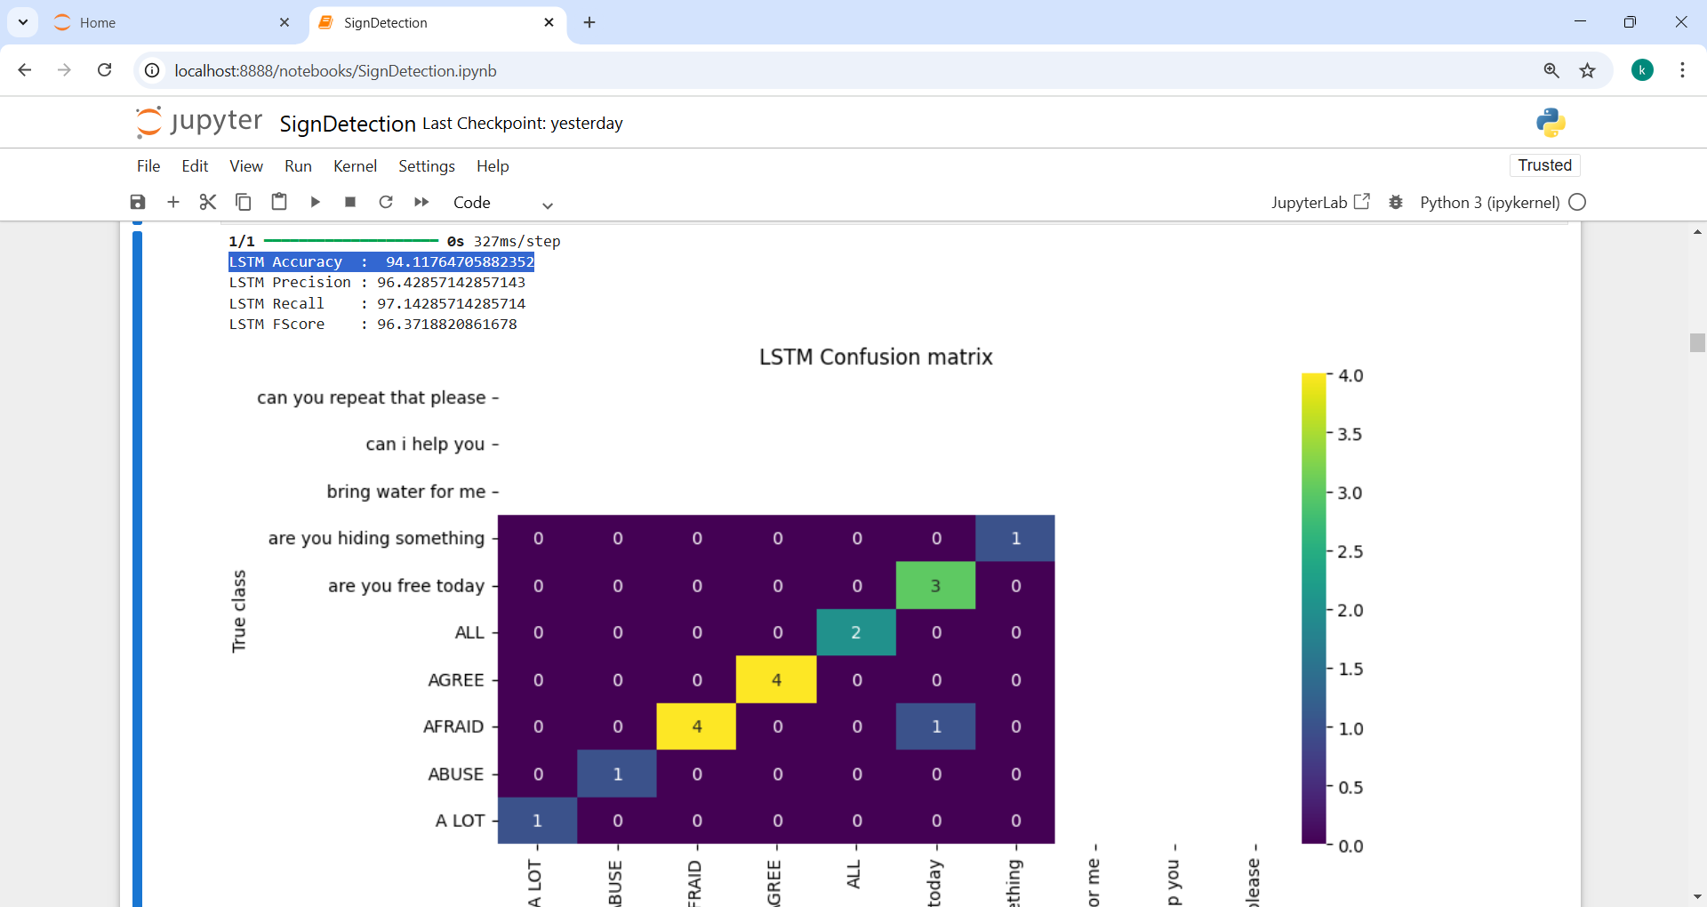

In above screen LSTM got 94% accuracy on gesture recognition and then in confusion matrix graph x-axis represents Predicted Labels and y-axis represents True Labels and then all different color boxes in diagonal represents correct prediction count and remaining blue boxes represents incorrect prediction counts which are 0.

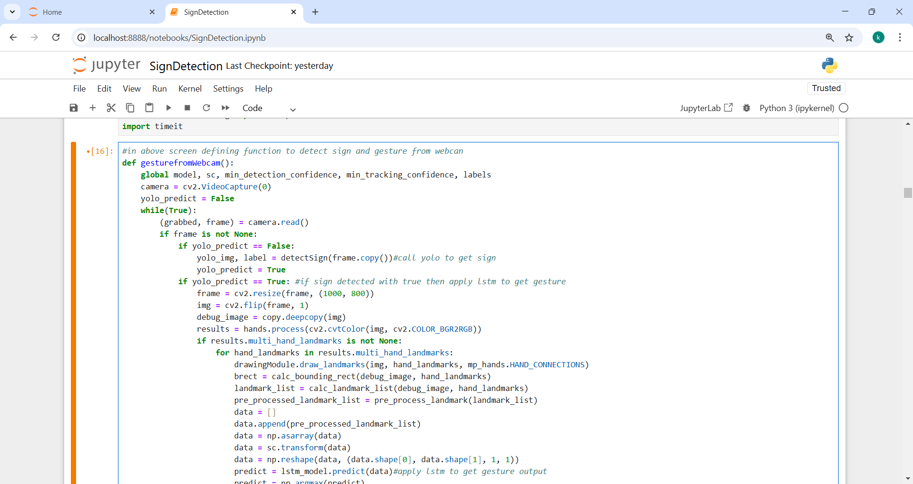

In above screen defining function to open webcam and then start detecting and recognizing signs and gesture. Run all blocks to get below window

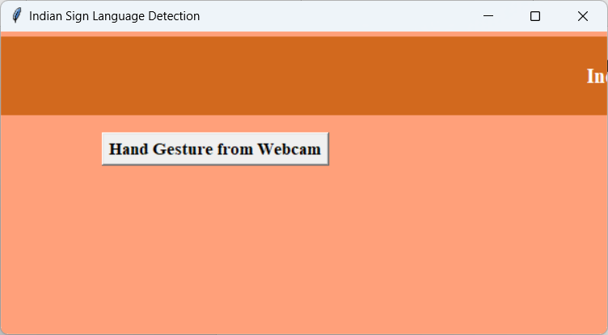

In above screen click on ‘Hand Gesture from Webcam button to start webcam and get below page

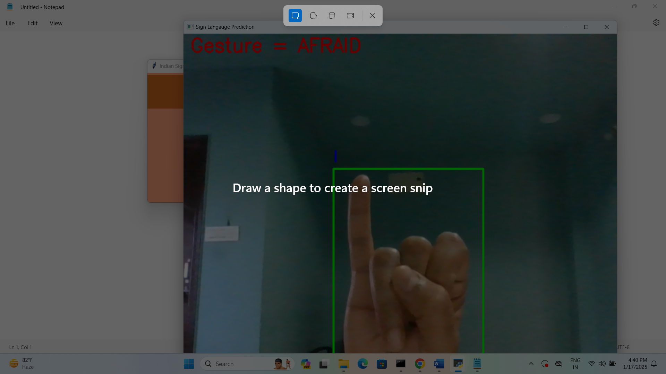

In above screen in red bounding box can see hand yolo detected hand sign as ‘I’ and then LSTM detected that gesture as ‘Afraid’ and similarly you can show any sign and then YOLO and LSTM will perform prediction. Above sentence can be read as ‘I Afraid’. All Yolo11 detected signs are in blue color and gesture is in red colour

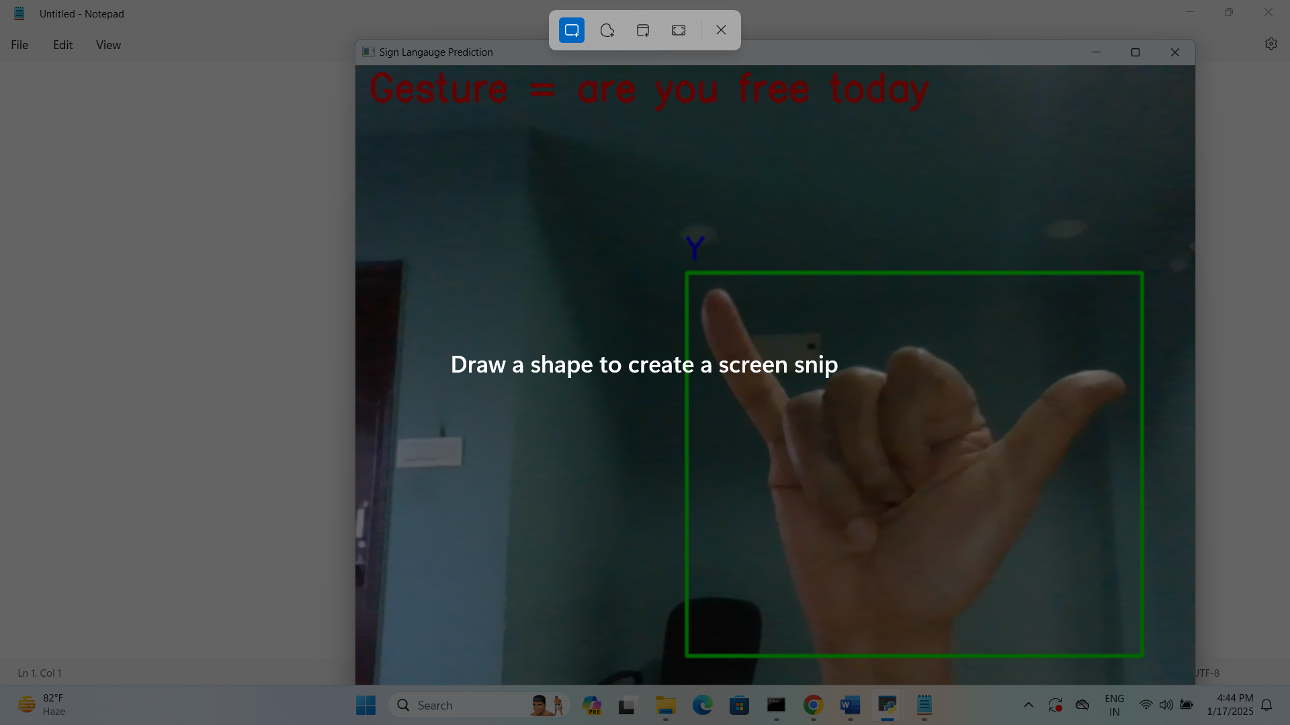

In above screen yolo11 detected sign as ‘Y’ and LSTM detected gesture as ‘are you free today’ so sentence can be form as ‘Y are you, free today’.

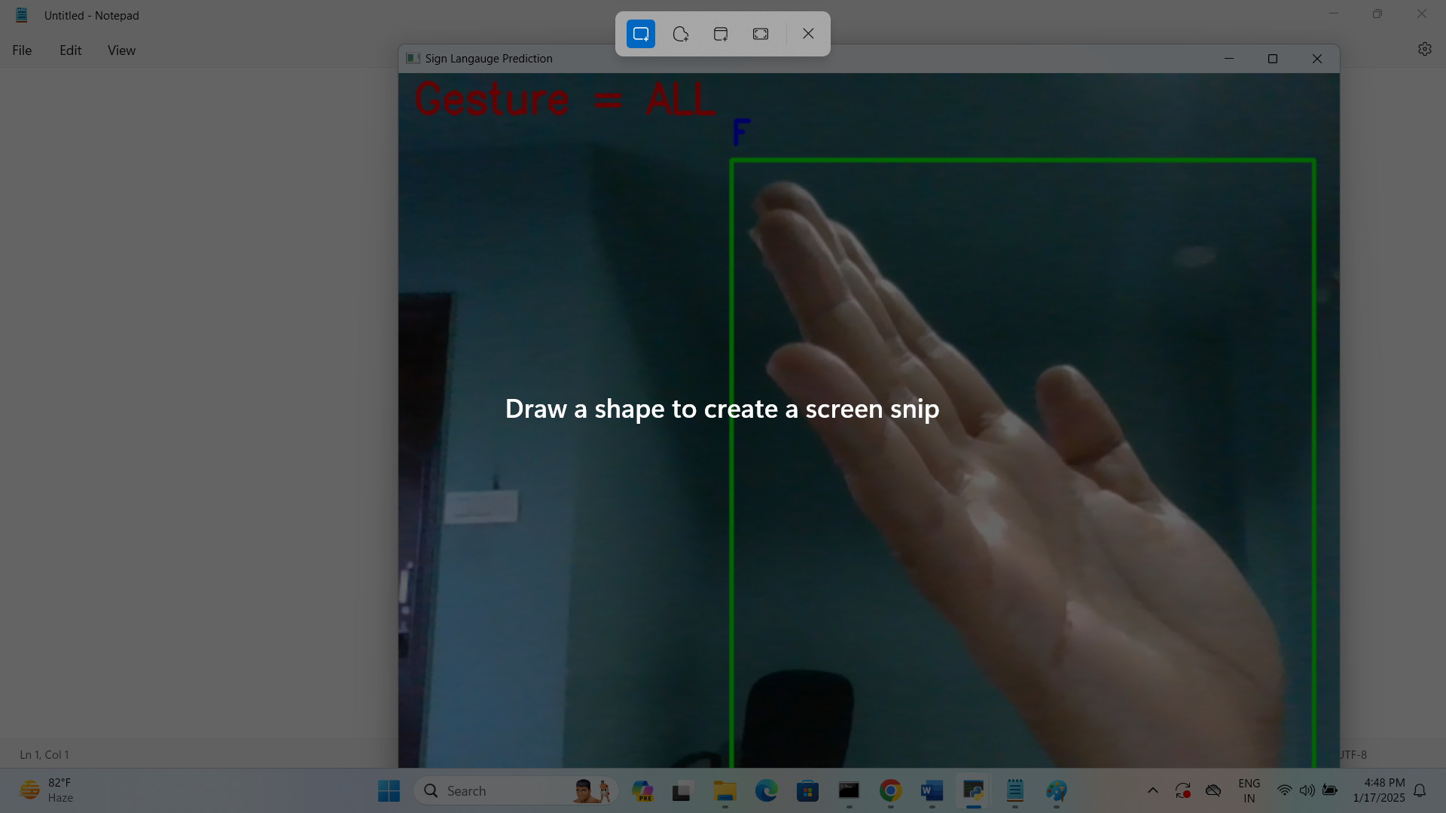

In above screen gesture detected as ‘ALL’ and sign detected as ‘F’. Similarly see signs and gesture images from Data and Dataset folder and then make similar hand position to get accurate prediction.